EX. NO.: 15
TITLE
DCL COMMANDS – GRANT, REVOKE
AIM
To learn how to use various DCL commands such as GRANT and REVOKE.

PROCEDURE
- Select the MobileDB database.
- Create a user for performing the DCL operations.
- Grant privileges to the user using the GRANT command.
- Verify the granted privileges using the SHOW GRANTS command.
- Revoke a privilege from the user using the REVOKE command.
- Verify the revoked privilege using the SHOW GRANTS command.
- Observe and verify the output.

COMMANDS
1. Create User
CREATE USER 'labuser'@'localhost'
IDENTIFIED BY 'Lab@123';

2. Grant SELECT Privilege
GRANT SELECT
ON MobileDB.MobileSales
TO 'labuser'@'localhost';

3. Verify GRANT
SHOW GRANTS FOR 'labuser'@'localhost';

4. Grant INSERT and UPDATE Privileges
GRANT INSERT, UPDATE
ON MobileDB.MobileSales
TO 'labuser'@'localhost';

5. Verify the Privileges
SHOW GRANTS FOR 'labuser'@'localhost';

6. Revoke UPDATE Privilege
REVOKE UPDATE
ON MobileDB.MobileSales
FROM 'labuser'@'localhost';
7. Verify REVOKE
SHOW GRANTS FOR 'labuser'@'localhost';

OUTPUTS
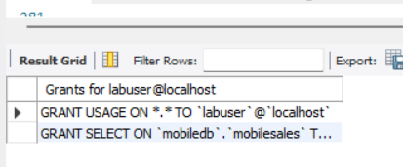

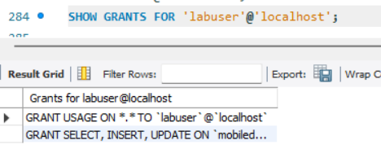
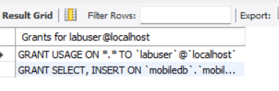

RESULT
Thus the DCL commands GRANT and REVOKE SQL were executed successfully and the result was verified.

